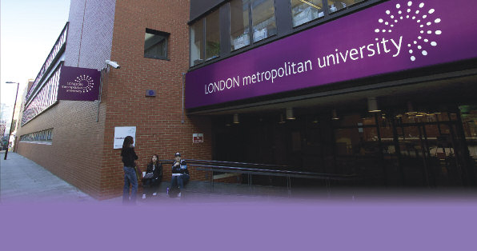
Summer School at London Metropolitan University
Depart Moscow Sunday, 1st July. Depart London Sunday, 15th July

London Metropolitan University is one of Britain’s largest Universities, based in the city, north and east of London. London Met educational credentials stretch back over 150 years. It is closely associated with the business, academic and professional life of one of the world’s great capital cities.
You can choose the schools on:
- Public Administration £1180 or
- Diplomacy and Global Governance £1180
Price includes:
- 14 nights accommodation
- Tuition and course costs
- Free travel in inner London
- Programmed excursions and sightseeing tours
- Farewell picnic
- Certificate of completion
Additional Costs:
- Flights – 21 000 Roubles
- Visa – 3 750 Roubles
- Airport transfers (except arrival in London)
- Food - £250-300
- Additional optional entertainment programme
Location:
- The Summer School programme is based at City campus in the heart of London, at the edge of one of the world’s major financial centres, within easy reach of the capital’s many attractions
- All courses are held in Goulston Street building close to both Liverpool Street and Aldgate underground train stations.
Summer School Courses:
- are taught by the University’s friendly and experienced subject specialists
- last for two weeks, including visits of academic and cultural interest and an intensive academic programme
- are open to participants from all over the world and have a friendly atmosphere
- are taught at a central London location.
Summer School
- offers a lively optional social programme as well as guidance and advice on places to visit while you study in London
- includes access to the University facilities, including; sports facilities, web resources and the library (on a non borrowing basis) for the duration of the course
Aims of the summer school:
- To introduce you to your chosen subject areas in Law, Public Administration, Diplomacy and Global Governance
- To develop your skills in problem solving and group work
- To develop your skills working in English
The Schedule:
- Classroom activities and visits – eg. legal London walk, visit to Foreign and Commonwealth Office, a Local Council, Parliament, London Development Agency, etc.
- Special visits associated with all programmes – central London orientation, coach and river tour, Oxford, the London Olympic Sites, Greenwich and the ‘Thames Gateway’, final picnic
- Optional visit programme – eg. ‘Club night’ in London (own cost), theatres, galleries, museums, discos, etc.
Contact details:
Elena Leonidovna Guseletova – Head of International Relations Department, NRU HSE
e-mail: eguseletova@hse.ru
tel: 495-628-9609

